**Name :- Prabhat Kumar**

**Session1**

**Project;- Constructing an arithmetic calculator**

**Project objective:**

As a developer, write a program to create an arithmetic calculator.

**Background of the problem statement:**

As a developer, write a Java code to create a calculator to perform the four basic arithmetic operations (addition, subtraction, multiplication, and division).

**Using Switch case :-**

**package** com.simplilearn.demo;

**import** java.util.Scanner;

**public** **class** calculator {

**public** **static** **void** main(String[] args) {

**char** operator;

**int** num1, num2, result;

Scanner input = **new** Scanner(System.***in***);

System.***out***.println("Choose an operator: +, -, *, or /");

operator = input.next().charAt(0);

System.***out***.println("Enter first num");

num1 = input.nextInt();

System.***out***.println("Enter second num");

num2 = input.nextInt();

**switch** (operator) {

**case** '+':

result = num1 + num2;

System.***out***.println(num1 + " + " + num2 + " = " + result);

**break**;

**case** '-':

result = num1 - num2;

System.***out***.println(num1 + " - " + num2 + " = " + result);

**break**;

**case** '*':

result = num1 * num2;

System.***out***.println(num1 + " * " + num2 + " = " + result);

**break**;

**case** '/':

result = num1 / num2;

System.***out***.println(num1 + " / " + num2 + " = " + result);

**break**;

**default**:

System.***out***.println("Invalid operator!");

**break**;

}

input.close();

}

}

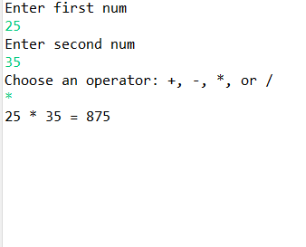

**Using if else loop:-**

**package** com.simplilearn.demo;

**import** java.util.Scanner;

**public** **class** ifcal {

**public** **static** **void** main(String[] args) {

**char** operator ;

**int** num1, num2 , result;

Scanner sc= **new** Scanner(System.***in***);

System.***out***.println("Enter first num");

num1 = sc.nextInt();

System.***out***.println("Enter second num");

num2 = sc.nextInt();

System.***out***.println("Choose an operator: +, -, *, or /");

operator = sc.next().charAt(0);

**if**(operator=='+') {

result = num1 + num2;

System.***out***.println(num1 + " + " + num2 + " = " + result);

}**else** **if**(operator=='-') {

result = num1 - num2;

System.***out***.println(num1 + " - " + num2 + " = " + result);

}

**else** **if**(operator=='*') {

result = num1 * num2;

System.***out***.println(num1 + " * " + num2 + " = " + result);

}

**else** **if**(operator=='/') {

result = num1 / num2;

System.***out***.println(num1 + " / " + num2 + " = " + result);

}

}

}